The pseudocode I used for the program is as follows:

1. Introduce the program;
2. Appropriately declare and input the number as string;
   1. Use it as an argument to call the method in another class that transforms the number into the name of the month;
   2. Allow for a little error checking in the class that converts;
3. Output the month using a method in the main program;
   1. if you want to check for more Goto 2; else
   2. Say goodbye;
4. Say goodbye;

The main program, NumberToMonth, consists of the input statements using JOptionsPane and 4 methods:

1. welcome(): introduction to the program and what it does.
2. EnterNumber(): this is the method where the request for input actually takes place and the call to the conversion method, NameOfMonth. It also creatively returns a string argument, which the displayMsg method uses for its output.
3. displayMsg(): this method is used for output, again using JOptionPane.
4. goodbye(): this method greets users of the program prior to exiting.

Methods b and c were placed in a do…while loop to allow for multiple attempts or multiple usage of the program without having to restart it.

An error message was inserted into the NameOfMonth class to ensure that only valid entries were made. Furthermore, the string that was sent to the class was converted into an integer to aid manipulation as an integer that they truly are. It would have been more straightforward to use the switch statement given in the hint, but I chose to implement the conversion using the if…else if…else statement.

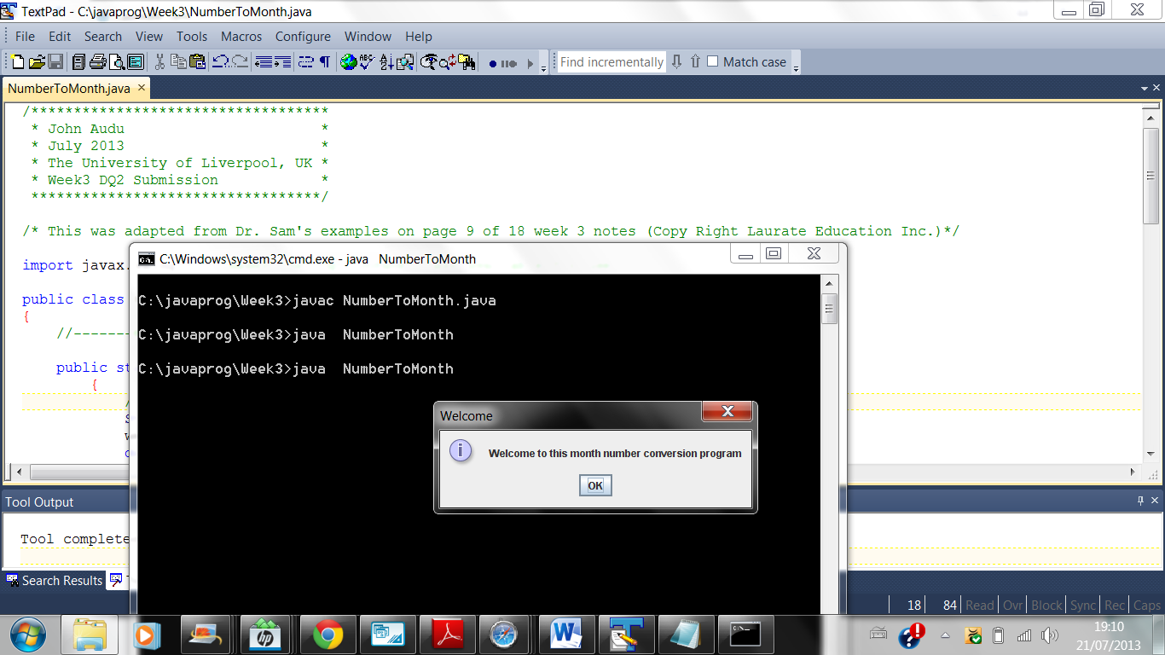

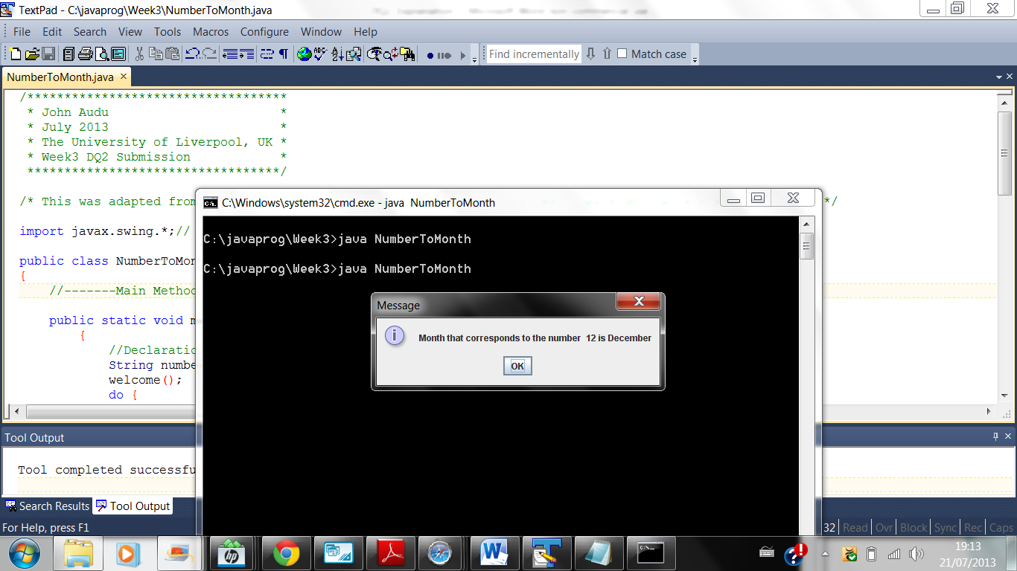

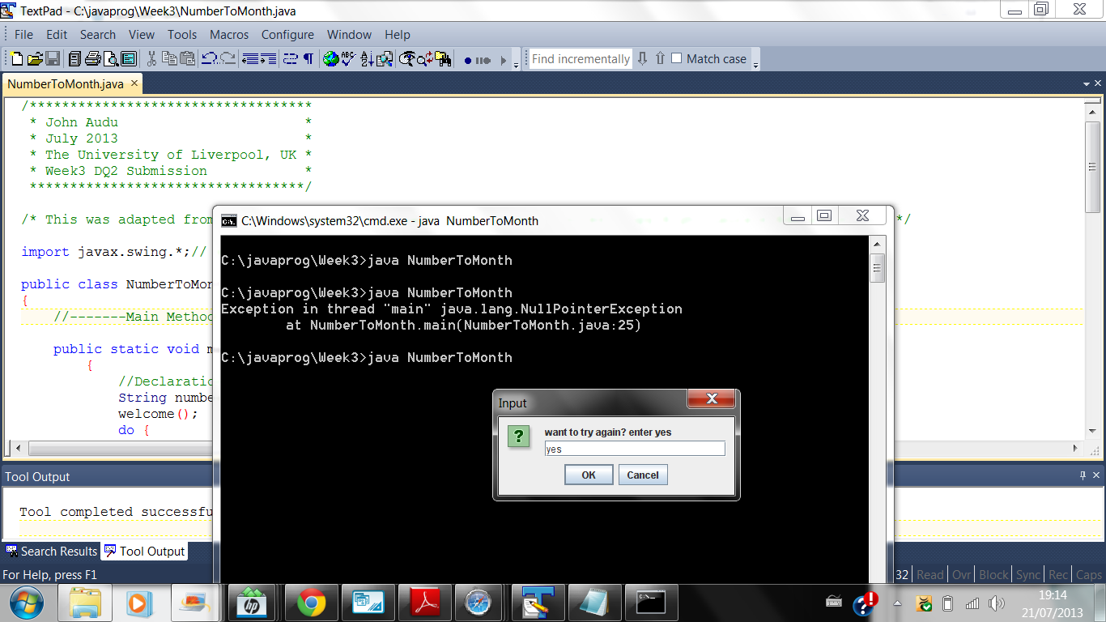

# Bibliography

Deitel, P. & Deitel, H., 2012. *Java How To Program.* 9th ed. Boston: Pearson EDucation Inc..

Laureate Education B.V., 2000-2007. *Java Programming.* [Online]   
Available at: https://elearning.uol.ohecampus.com/bbcswebdav/xid-584666_4  
[Accessed 7 July 2013].